This is a simple TCP socket program in JAVA, the following below is instruction on how to execute it;

1. First open 2 command or PowerShell, then locate ‘Server.class’ and ‘Client.class’ file and enter “java Server “and “java Client “on each command. 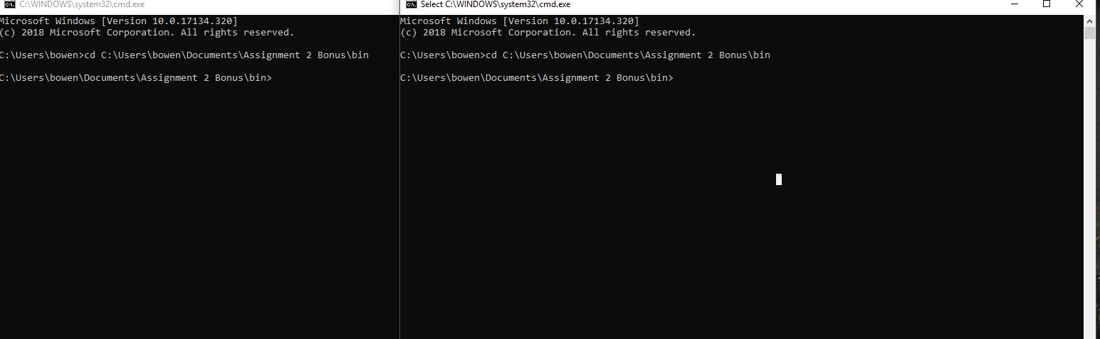

2.Server and Client should be able to communicate with each other by enter text in text area below then press Enter on the keyboard or send button on the screen.

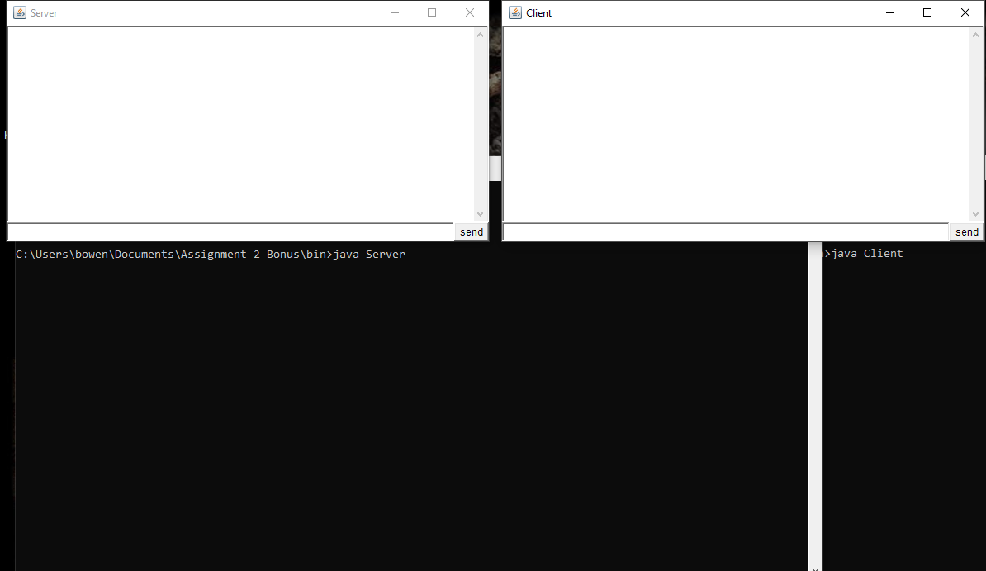

3.Enter hamming code on the Client side, the detected result will be display on the command line of the server side at back. 